10 Dangerous Goods

[NX6 2.1.2]

10.1 Definition

Dangerous goods are defined as substances or materials which have been determined by the Secretary of Transportation to be capable of posing an unreasonable risk to health, safety, and property when transported in commerce and which has been so designated.

Acme Corp Flight Department is not a carrier of dangerous goods, with the exception of certain items listed in 10.2 Exceptions. This section is intended as a familiarization of what is considered dangerous goods and the proper markings for shipping them.

10.1.1 Dangerous Goods Categories

Dangerous goods fall into nine basic categories:

1. Explosives

2. Gases

3. Flammable liquids

4. Flammable solids or substances

5. Oxidizing substances

6. Poisonous and infectious substances

7. Radioactive substances

8. Corrosives

9. Other Regulated Materials (ORMs)

Dangerous Goods warning labels have been developed for each category.

10.1.1.1 Class 1 – Explosives

Any chemical compound, mixture, or device that is designed to function by explosion, which is a substantially instantaneous release of gas and heat. Examples: Dynamite, blasting caps, fireworks, paper caps for toy pistols, and percussion caps. The markings for Class 1 materials are as follows:
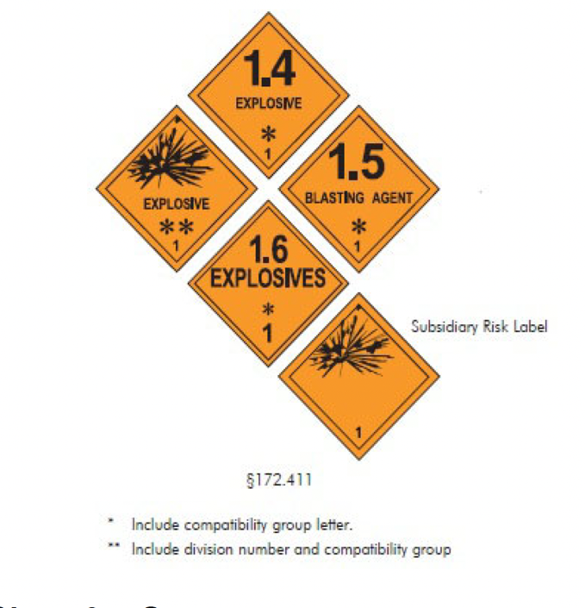

10.1.1.2 Class 2 – Gases

Compressed, liquefied, or dissolved under pressure. Examples: Carbon monoxide, hydrogen, oxygen, chlorine, carbon dioxide, and neon.
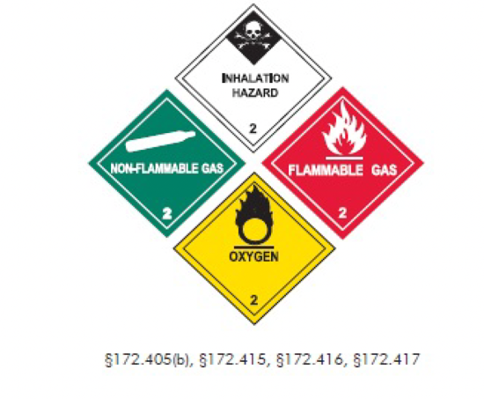

10.1.1.3 Class 3 – Flammable Liquid

A liquid having a flash point below 100°F. Pyroforic liquid is any liquid that ignites spontaneously in dry or moist air at or below 130°F. Combustible liquid is any liquid having a flash point at or above 100°F and below 200°F. Examples: Kerosene and butane.
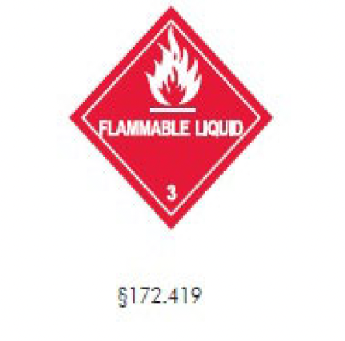

10.1.1.4 Class 4 – Flammable Solids or Substances

Any solid material (other than an explosive) that is liable to cause fire through friction, retained heat, manufacturing, or processing. It can be ignited readily and burns so vigorously and persistently, that it creates a serious transportation hazard. Examples: Metallic Sodium and Potassium.
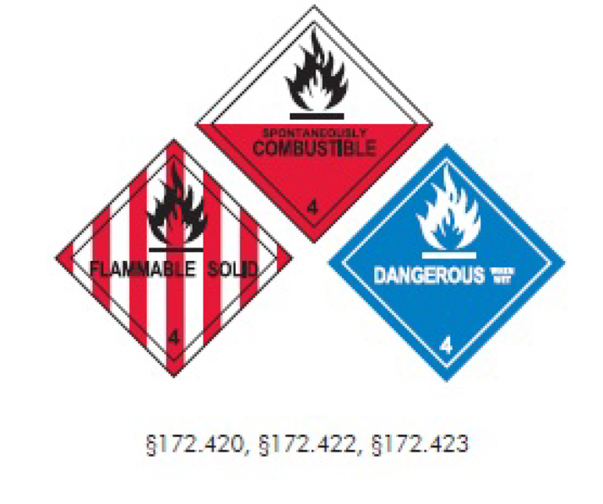

10.1.1.5 Class 5 – Oxidizing Substances

Any substance, such as chlorate, inorganic peroxide, or nitrate, that accelerates the combustion of organic matter by readily yielding oxygen. Examples: Hydrogen Peroxide, Chlorine Bleaching Powder, Ammonium Nitrate, Lauroyl Peroxide (bleaching agent), and Succinic Acid Peroxide (antiseptic).
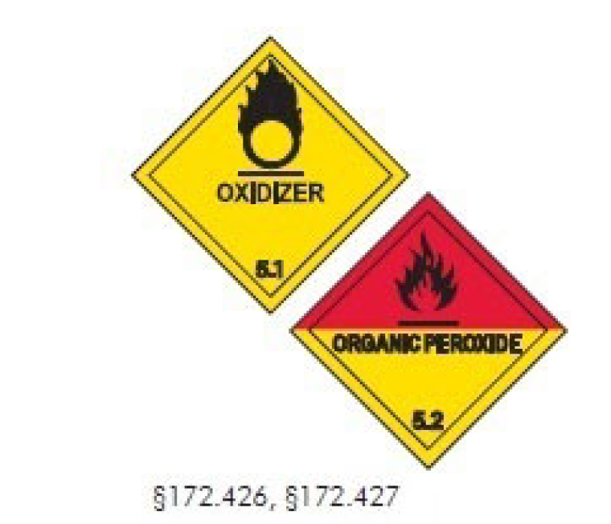

10.1.1.6 Class 6 – Poisonous and Infectious Substances

Poisonous Materials are liquids or solids so toxic to humans that they are a hazard to health during transportation. An irritant is a substance that, upon contact with fire or air, gives off dangerous or intense fumes. Etiologic Agents are living microorganisms or their toxin that causes (or may cause) human disease. Examples: Nitric Oxide, Arsenic, Strychnine, and Cyanide irritants (tear gas and chemical mace).
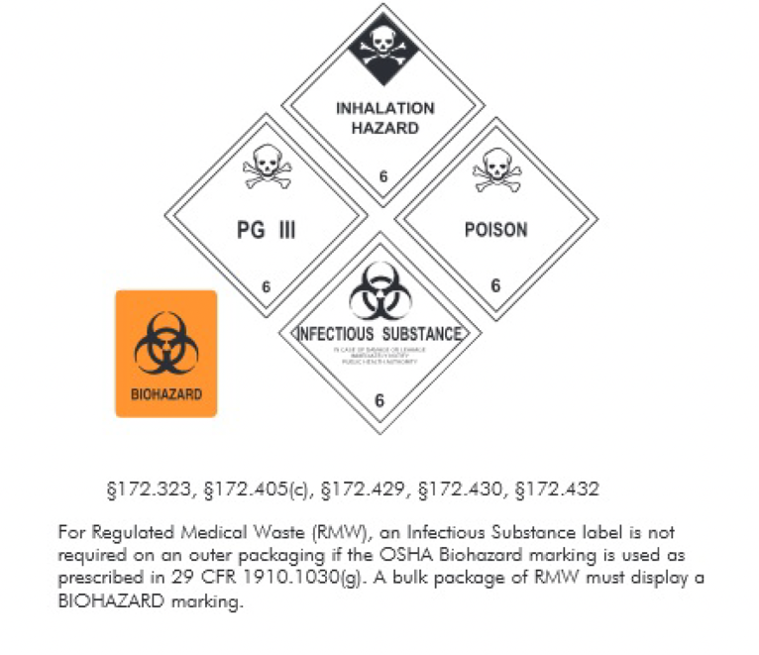
10.1.1.7 Class 7 – Radioactive Substances

A liquid or solid that spontaneously gives off ionizing radiation.
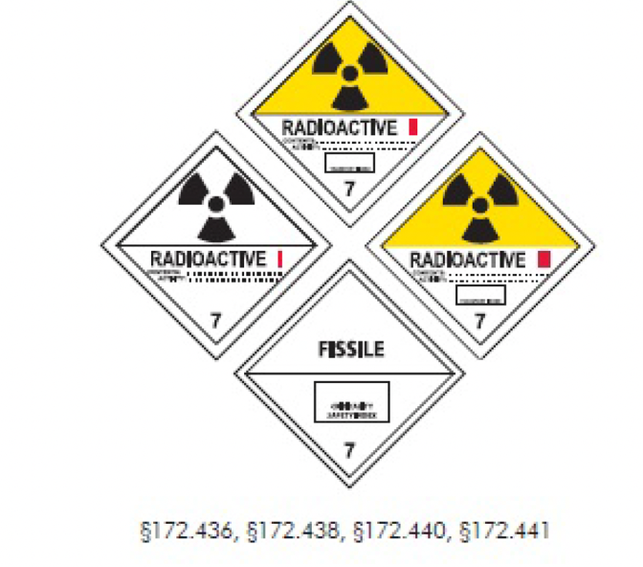
10.1.1.8 Class 8 – Corrosive

Any liquid or solid that causes visible destruction or irreversible damage to human tissue. It may also be a liquid that has a severe corrosion rate on steel or aluminum. Examples: Paint remover, soda lime, and battery acid. Wet spillable batteries when properly packaged would be considered an acceptable item.
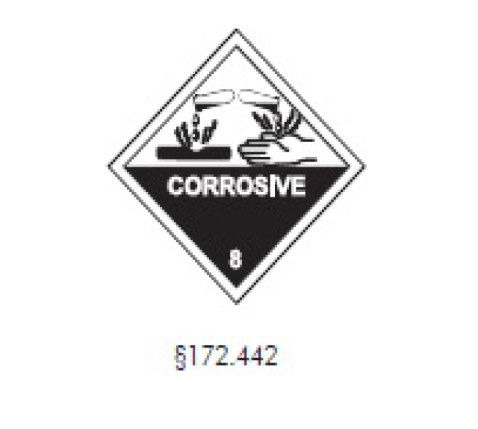
10.1.1.9 Class 9 – Miscellaneous Dangerous Substances

Any material that may pose an unreasonable risk to health and safety or property when transported in commerce and does not meet any of the definitions of the hazard classes specified previously. Examples: Carbon dioxide solid (dry ice), sodium fluoride, manganese dioxide (matches), and magnetized materials. Dry ice, when properly packaged, in the maximum amount of four lbs. per passenger, is an acceptable item.
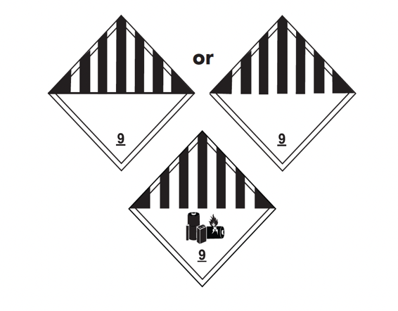

10.2 Exceptions

Any item or package that has a Dangerous Goods label, or is marked ORM, cannot be accepted for transportation, unless the item is listed in the exceptions section. These items commonly carried by passengers are not considered dangerous in small quantities:

a. Personal toilet articles not to exceed 75 ounces per person (example: hairspray, aerosol perfume)

b. Alcoholic beverages

c. Aerosol containers

d. Small arms ammunition in checked luggage

e. Dry ice is categorized as ORM but is not considered hazardous in the above quantity restrictions

Suspicion of any dangerous goods present in authorized areas or shipment of such material must be reported to the PIC immediately.

Acme Corp Flight Department will remind passengers of the Dangerous Goods policy in a note at the bottom of the flight itinerary.

10.3 Dangerous Goods Emergencies

This section provides information on how to respond to an inadvertent spill or release of dangerous goods aboard the aircraft.

10.3.1 General Procedures

a. Notify the PIC

b. Assess situation (fire is always a concern)

c. Identify the material ASAP

d. Approach the “danger area” cautiously

e. Avoid inhaling vapors and fumes

f. Do not assume gases and vapors are harmless due to lack of odor

g. Do not walk through contaminated area

h. Do not attempt cleanup without the proper equipment

Once risk is determined and the substance is identified, or if unable to accurately identify the material:

10.3.2 Notify Authorities

a. Director of Aviation

b. Airport manager

c. Public safety personnel (ARRF, law enforcement, etc.)

d. Request assistance

10.3.3 If No Spill, or No Fire

a. Notify PIC

b. Attempt to identify material

c. Assess risks

d. Call CHEMTREC (if required)

10.3.4 Land to Remove Danger

10.3.4.1 Fire

a. Extinguish fire

b. Do not use water without identifying substance

c. Notify PIC

d. Utilize respiratory protection (smoke hoods, wet towels, etc.)

e. Move passenger away from area

f. Contain the fire site

g. Attempt to identify the material

h. Emergency landing

i. Notify fire personnel ASAP

10.3.4.2 Spillage or Leakage

a. Notify PIC

b. Move PAX away from area

c. Use respiratory protection (smoke hoods, wet towels, etc.)

d. Do not allow contact with any spilled material

e. Do not spray with H2O until material identified

f. Call CHEMTREC (if required)

g. Land to remove hazard

10.3.4.3 Other Resources

These agencies are available to answer questions regarding a hazardous material and/or dangerous good incident or accident.:

CHEMTREC (24 hour) 800-262-8200

National Response Center (NRC) 800-424-8802

Center for Disease Control 800-311-3435

Local Department of Emergency Services

