1 Company Organization

  - Acme Corp Flight Department Structure
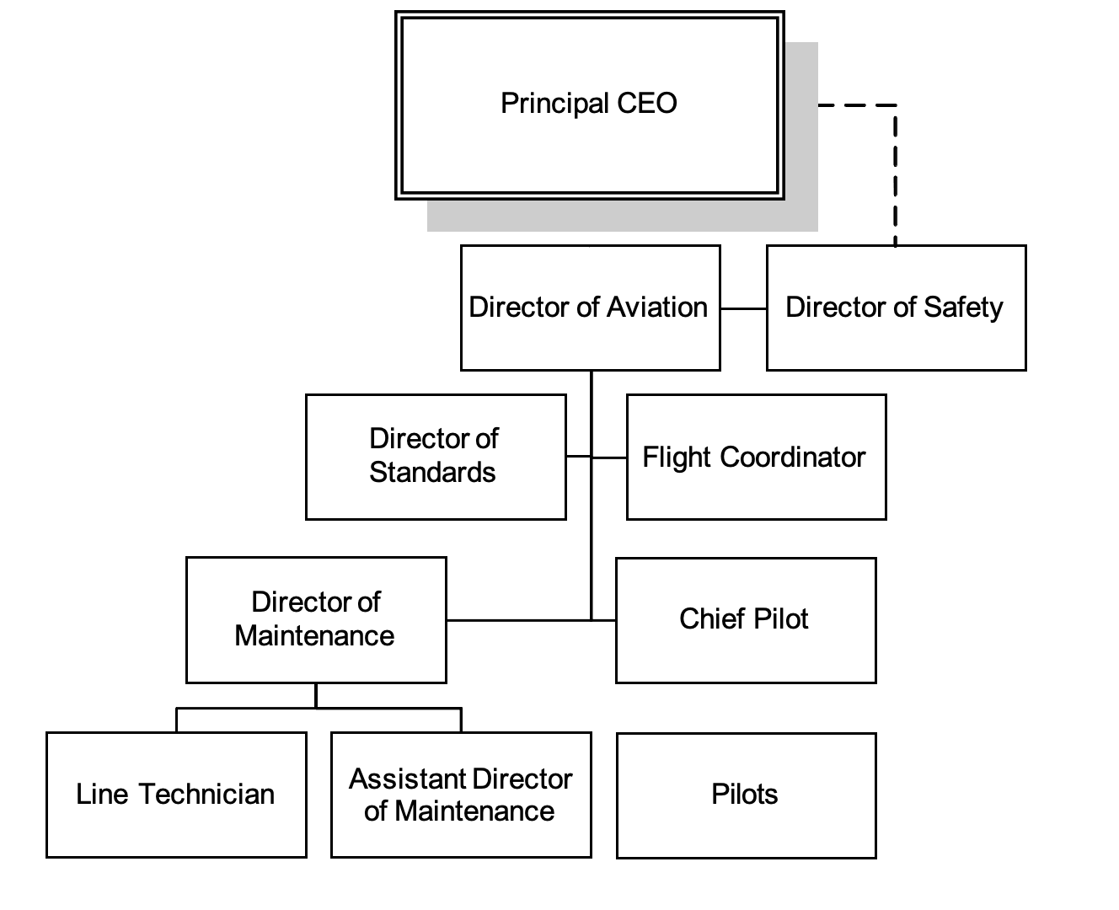
1.2 Duties, Responsibilities, and Qualifications

Following are the duties, responsibilities, and qualifications of the management and operating personnel of Acme Corp Flight Department. Personnel in job categories have the authority to carry out their assigned duties and responsibilities, including their safety tasks, with the appropriate notification and coordination of their direct supervisors or other appropriate company officials.
1.2.1 Director of Aviation Reports to: Principal CEO
Supervises: Director of Maintenance, Chief Pilot, Director of Safety, Director of Standards, Flight Coordinator
1.2.1.1 Qualifications

[NX6 2.1.1.6 and NX6 3.3.1.5]

Education: College degree or equivalent experience
Experience: Five years pilot and/or management experience
1.2.1.2 Position Description

The Director of Aviation is responsible for managing the Acme Corp aircraft in order to support the travel requirements of company personnel, customers, and guests. This position includes the responsibility for carrying out our company’s mission and objectives while ensuring that safety is never compromised.

1.2.1.3 Duties and Responsibilities

[NX6 3.4.2.3.1]

a. Leads Acme Corp to maintain a culture of safety with efficient procedures that support customer service
b. Provides leadership and direction for highly motivated professional pilots and support staff
c. Ensures reliability, safety, service, security, and maintains legal compliance with appropriate regulations and company policies
d. Maintains compliance with company policies and procedures
e. Creates documents to meet the FAA rules and regulations
f. Manages and develops aircraft operating procedures
g. Manages the pilot training standards
h. Prepares budgets per corporate requirements
i. Ensures that Flight Operations aircraft are maintained in the most up to date status
j. Oversees the Acme Corp RVSM program
k. Acme Corp with maintenance
l. Selects and maintains a staff of professionals of the highest caliber

1.2.2 Chief Pilot

Reports to: Director of Aviation
Supervises: Pilots

1.2.2.1 Qualifications

[NX6 2.1.1.6, NX6 3.3.1.5 and NX6 3.9.4.1.1]

Education: College degree or equivalent experience
Licenses: ATP, type rating in Company aircraft English proficiency
Restricted Radio Telephone Operator Permit Valid automobile driver’s license
Valid passport
Medical: FAA First-Class Medical Certificate
Flight Time: 5000 hours total time
2000 hours multiengine turbine
Experience: Three years pilot and/or management experience

1.2.2.2 Position Description

The Chief Pilot is responsible for the flight operations of Acme Corp Flight Department aircraft. The Chief Pilot works closely with the other members of the management team to continually evaluate and improve the Flight Department, and the day to day operations.

1.2.2.3 Duties and Responsibilities

[NX6 3.4.2.3.1]

a. Works within Acme Corp Flight Department to maintain a culture of safety with efficient procedures that support customer service
b. Acts as Pilot in Command (PIC) in company aircraft, as required
c. Monitors appropriate compliance of flight operations with department standards
d. Responsible for crewmember training, including developing and implementing in house or contract training to meet regulatory and company objectives
e. Maintains crew records and generates reports
f. Develops Standard Operating Procedures (SOPs) and maintains the professional standards of Acme Corp Flight Department crewmembers
g. Issues directives and notices to the crewmembers, as required
h. Ensures that airports and routes served by Acme Corp Flight Department are operationally suitable and meet company requirements
i. Acts on and distributes accident, incident, and other occurrence reports
j. Optimizes the aircraft and crew schedules
k. Creates, maintains, and implements Company Operations Manual to be used by crewmembers of the Acme Corp Flight Department

1.2.3 Captain

Reports to: Chief Pilot
Supervises: Crewmembers on assigned flights when acting as PIC
1.2.3.1 Qualifications

[NX6 2.1.1.6, NX6 3.3.1.5 and NX6 3.9.4.1.1]
Airman Certificate: FAA ATP Appropriate Category, Class, and Type
Ratings, with statement of English proficiency
Medical Certificate: FAA First Class
FAA Sanctions
Last Five Years: None
Accidents Or Incidents
Last Five Years: None
Type Rated: Yes, in type operated by Acme Corp
LLC with FAA approved simulator training. A specific safety training event (i.e. Upset Training) may replace a simulator training event once every 36 months.
Total Time: 4000
Category: 4000
PIC Category: 2000
Class (Multi-Engine): 2000
PIC Class: 1500
Specific Type
and Model: 100
Instrument Actual (PIC): 300
Turbine: 1000
Turbojet, PIC: 5000
1.2.3.2 Position Description
The Captain, when assigned as the PIC, is responsible for the safe transport of company personnel on domestic and international flights. The Captain ensures aircraft meets performance for airworthiness, researches current weather, and calculates and files flight plans.

1.2.3.3 Duties and Responsibilities

[NX6 2.7.2.1 and NX6 3.4.2.3.1]

a. Works within Acme Corp to maintain a culture of safety with efficient procedures that support customer service
b. Retains final authority for the safe operation of the aircraft
c. Ensures that proper documents are on the aircraft
d. Instructs and directs crewmembers so that they understand fully and completely what duties they are expected to perform
e. Makes decisions related to the start, delay, or cancellation of the flight, or deviation from a planned destination when operating conditions dictate
f. Prepares or supervises preparation of flight plan considering such factors as altitude, terrain, weather, range, weight, cruise control data, airport facilities, and navigational aids
g. Performs tasks associated with operating the aircraft while away from home base
h. Ensures that a flight plan or other authorized flight locating procedures are followed on each flight
i. Reports known or suspected FAA violations or incidents promptly to the Chief Pilot
j. Ensures that crewmembers provide passengers with the appropriate briefing for each phase of flight
k. Ensures that the required passenger ground handling and transportation is in place
l. Completes relevant trip documentation at the conclusion of the flight
m. Ensures that crewmembers on assigned flights are fully qualified, properly rested, prepared for flight, have required licenses and certificates in their possession, and are briefed on specific requirements of the trip

1.2.4 Second in Command

Reports to: Chief Pilot
Supervises: N/A
1.2.4.1 Qualifications

[NX6 2.1.1.6, NX6 3.3.1.5 and NX6 3.9.4.1.1]
Airman Certificate: FAA ATP Appropriate Category, Class, and Type
Ratings, with statement of English proficiency Medical Certificate: FAA First Class renewed every six months FAA Sanctions
Last Five Years: None
Accidents or Incidents
Last Five Years: None
Type Rated: Yes, in type operated by Acme Corp
LLC with FAA approved simulator training. A specific safety training event (i.e. Upset Training) may replace a simulator training event once every 36 months
Total Time: 2000
Category: 1500
PIC Category: 500
Class (Multi-Engine): 1500
PIC Class: 100
Specific Type
And Model: 0
Instrument Actual (PIC): 75
Turbine: 500
Turbojet, PIC: 50
1.2.4.2 Position Description
The Second in Command (SIC) performs the duties of on Acme Corp aircraft and are responsible to remain involved with the safe operation of the flight. The SIC may perform takeoffs and landings as directed by the PIC.

1.2.4.3 Duties and Responsibilities

[NX6 3.4.2.3.1]
a. Works within Acme Corp to maintain a culture of safety with efficient procedures that support customer service
b. Functionally responsible to the PIC of the flight for the conduct and execution of assigned duties in accordance with federal, state, and local airport rules and regulations
c. Performs duties as assigned during flight preparation and inflight
d. Assists PIC in operation and flight of the aircraft
e. Is prepared to assume inflight duties of PIC if the PIC becomes incapacitated
f. Provides passengers with the appropriate briefing for each phase of flight as directed by the PIC
g. Assists with aircraft preflight, records, and flight documents, as required
h. Serves and assists passengers to ensure their safety and comfort
i. Maintains up to date technical job knowledge in aircraft systems, avionics, and ATC

1.2.5 Director of Safety

Reports to: Director of Aviation
Supervises: N/A

1.2.5.1 Qualifications

Education: High school diploma, or equivalent
Experience: Knowledge of aviation related safety programs, safety standards applicable to aviation operations, accident causation and prevention theory, safety margins, risk management techniques, and human error theory Knowledge of CFRs

1.2.5.2 Position Description

The Director of Safety works in liaison with the Director of Aviation on matters related to safety. The Director of Safety is responsible for all aspects of the SMS.

1.2.5.3 Duties and Responsibilities

[NX6 3.4.2.3.1]

a. Works to maintain and promote the Acme Corp Flight Department safety culture while employing efficient procedures that support customer service
b. Acts as resident expert on safety related matters
c. Ensures that safety program elements are carried out
d. Manages the Acme Corp Flight Department SMS on a daily basis
e. Communicates safety issues within the Flight Department.
f. Monitors compliance with applicable safety standards (e.g. DOT, FAA, OSHA, EPA)
g. Manages FOQA data
h. Manages Fatigue Risk Management Program

1.2.6 Director of Maintenance

Reports to: Director of Aviation
Supervises: Assistant Director of Maintenance, Line Technician
1.2.6.1 Qualifications

Education: High school diploma or equivalent
Formal maintenance training on Acme Corp specific aircraft required
Licenses: FAA Airframe and Powerplant license
Inspection Authorization (preferred) Valid automobile driver’s license Valid passport
Medical: N/A
Experience: Five years maintenance experience with high performance turbine aircraft. Experience with Acme Corp specific aircraft preferred
1.2.6.2 Position Description

The Director of Maintenance is responsible for aircraft maintenance, including supervising technicians and working directly on company owned and operated aircraft to achieve the highest level of safety and dispatch.
1.2.6.3 Duties and Responsibilities

[NX6 3.4.2.3.1]

a. Works within Acme Corp to maintain a culture of safety with efficient procedures that support customer service
b. Implement the maintenance standards, methods, and procedures
utilized by the company to ensure compliance with the company operations manual, CFRs, and manufacturers recommendations
c. Liaising with the national civil aviation authority on maintenance topics
d. Supervising aircraft maintenance staff
e. Liaising with all non-company persons or Approved Maintenance Organizations (AMOs) performing maintenance on Acme Corp aircraft
f. Ensure the proper completion of aircraft maintenance records as required by State regulations, manufacturers and company policy are established and maintained

g. Ensuring that Airworthiness Directives and Service Bulletins that effect Flight Department aircraft are complied with appropriately
h. Monitor and accomplish warranty administration for assigned aircraft
i. Participate in the flight department occupational health and safety program
j. Removing from service any aircraft that are unsafe, or that do not comply with national regulatory requirements
k. Establishing Flight Department safety policies and procedures for ground operations
l. Ensure that subordinate maintenance personnel are qualified to perform the maintenance procedures assigned in accordance with procedures set forth in the Company Operations Manual
m. Ensure that adequate tools, parts, materials, support equipment, and facilities are available for the work intended
n. Coordinate maintenance activities with the Director of Aviation, as required
o. Coordinate maintenance training requirements as addressed in the company operations manual with the Director of Aviation
p. While maintaining overall responsibility, delegate duties to qualified assistants as necessary
q. Develop budget information related to aircraft maintenance, spare parts, tooling, equipment, and base facilities as requested by Director of Aviation
r. When using “per diem” technicians for temporary replacement coverage, verify the qualifications and training status of each “per diem” and provide necessary training to meet company requirements
s. Undertake other duties and responsibilities as assigned by the Director of Aviation
t. Dispatches and receives aircraft at home base

1.2.7 Assistant Director of Maintenance

Reports to: Director of Maintenance
Supervises: N/A
1.2.7.1 Qualifications
Education: High school diploma or equivalent
Formal maintenance training on Acme Corp specific aircraft required
Licenses: FAA Airframe and Powerplant license
Valid automobile driver’s license Valid passport
Medical: N/A
Experience: Three years maintenance experience with high performance turbine aircraft. Experience with Acme Corp specific aircraft preferred
1.2.7.2 Position Description
The Assistant Director of Maintenance is responsible for completing assigned aircraft, engine, and avionics maintenance in a safe and timely manner.
1.2.7.3 Duties and Responsibilities
[NX6 3.4.2.3.1]
a. Works within Acme Corp to maintain a culture of safety with efficient procedures that support customer service
b. Assisting the Director of Maintenance as directed
c. Assisting in performing aircraft maintenance, servicing, and any other task related to maintaining a safe, compliant, airworthy aircraft
d. Supervising aircraft maintenance during MRO, FBO, AOG, events, when needed on location
e. Liaising with all non.company persons or Approved Maintenance Organizations (AMOs) as directed
f. Assisting to ensure that aircraft maintenance records as required by State/federal regulations, manufacturers and company policy are established and maintained
g. Assisting with communication about all applicable Airworthiness Directives, CB, ASCs, and Service Bulletins ensure appropriate compliance
h. Participate in the flight department occupational health and safety program
i. Help maintain established flight department safety policies and procedures for aircraft, and ground/hangar operations
j. Any other related tasks as assigned by his/her manager to accommodate the company’s business
k. Dispatches and receives aircraft at home base

1.2.8 Line Technician

Reports to: Director of Maintenance
Supervises: N/A
1.2.8.1 Qualifications Education: High School Diploma
Licenses: N/A
Experience: Aircraft interior and exterior cleaning preferred.
Minor building and equipment maintenance.

1.2.8.2 Position Description

Perform interior and exterior aircraft cleaning prior to and following company flights. Conduct general maintenance, repair, and upkeep of hangar facility, grounds, and ground support equipment/vehicles.
1.2.8.3 Duties and Responsibilities

a. Works within Acme Corp Flight Operations to maintain and promote a culture of safety and customer service throughout the organization
b. Performs interior and exterior aircraft cleaning
c. Performs hangar facility cleaning
d. Performs aircraft towing
e. Monitors refueling and de-icing functions
f. Performs line service functions for company and visiting aircraft
g. Assists Technicians as requested
h. Orders supplies as required to maintain aircraft stock and inventory control of cleaning supplies and equipment
i. Performs cleaning of department vehicles
j. Performs minor upkeep of the ground support equipment
k. Performs minor facility maintenance including routine plumbing, heating and electrical repairs, any repairs requiring outside contracting shall be coordinated through the Director of Maintenance
l. Performs minor maintenance of the department vehicles
m. Assumes supervisory duties in working with outside contractors for the facility

1.2.9 Flight Coordinator

Reports to: Director of Aviation
Supervises: N/A

1.2.9.1 Qualifications

Education: High school diploma required, college degree preferred
Licenses: Dispatchers license
Medical: N/A
Experience: Aviation scheduling and dispatching preferred Experience with computer software required

1.2.9.2 Position Description

Perform trip scheduling, flight crew, and passenger logistical support as required by the Director of Aviation and each trip PIC.

1.2.9.3 Duties and Responsibilities

a. Works within Acme Corp Flight Operations to maintain a culture of safety with efficient procedures that support customer service
b. Scheduling travel for executives on company aircraft or other lift alternatives such as charter
c. Coordinating aircraft handling and fueling with fixed base operators
d. Maintaining a flight following system
e. Coordinate travel schedule with maintenance schedule
f. Interfacing with flight crews, management, maintenance, and passengers
g. Scheduling ground transportation and accommodations
h. Arranging catering
i. Coordinate international trip requirements including EAPIS and customs, when necessary
j. Ensuring trip meets duty and rest requirements
k. Track qualification and training records for each Acme Corp crewmember
l. Assist crewmembers with currency requirements by tracking due dates

1.2.10 Director of Standards
Reports to: Director of Aviation
Supervises: Crewmembers on assigned flights when acting as Pilot in Command
1.2.10.1 Qualifications
Education: High school diploma or equivalent
Aircraft specific training, as required
Licenses: ATP with multiengine land rating
Type rating in Company aircraft English proficient
Valid automobile driver’s license Valid passport
Medical: FAA First-Class medical certificate
Experience: Three years pilot experience as Captain
1.2.10.2 Position Description
The Standards Captain oversees the flight standards program to develop and ensure flight crewmembers operate according to Acme Corp standard operating procedures and policies.

1.2.10.3 Duties and Responsibilities
a. Accountable for developing, monitoring, and enforcing the professional standards of the flight crews
b. Accountable for the overall effectiveness of the Acme Corp Safety Management System
c. Developing Standard Operating Procedures
d. Establishing and managing the Hazard Identification and Tracking System, in concert with the Director of Safety
e. Establishing and managing the Continuous Improvement Opportunity System, in concert with the Director of Safety
f. Maintain and monitor Risk Assessment Forms
g. Providing input to the Director of Aviation regarding the company operations manual, aircraft checklists, and all other flight crew Standard Operating Procedures
h. Participate in the flight department Occupational Health and Safety program
i. Monitoring flight crew performance
j. Administering company flight evaluations in accordance with the Company Check Pilot Manual
k. Manage the monthly training program
l. Administers the RNP AR validation program if used
m. Providing crews with an avenue to develop changes to Standard Operating Procedures
n. Assuming any responsibilities delegated by the Director of AviGaotioton Transmittal

1.2.11 Contract Pilots

Contract pilots will normally be assigned to PM duties when passengers are on board. Contract pilots must be SIC current as a minimum, hold the appropriate aircraft type rating and a current First-Class medical certificate. Currency can be waived by the Director of Aviation on a case by case basis. The Director of Aviation may designate contract pilots as left seat capable (with passengers.)

Prior to using a new contract pilot, the Director of Standards will provide a briefing to familiarize the pilot with normal Acme Corp passenger protocol and will complete an ASSET checklist as provided in paragraph 6.9 Aircraft Specific Survey and Emergency Training (ASSET). The Director of Standards will also ensure the Contract Pilot has access to the COM and, specifically, this section, Flight Operations.

A contract pilot may be allowed to serve as PIC or fly the aircraft from the left seat with passengers onboard if the pilot meets the requirements of xxx
6.1 Captain/PIC, with prior approval and appropriate designation by the CEO.

