3 Administration and Scheduling

3.1 Administration

This section defines hiring and employment policies for Acme Corp Flight Department employees and administrative procedures within the department.

3.2 Employment Policy

It is the policy of Acme Corp to hire the best qualified person for any open position. Internal candidates may be considered before outside sources are pursued, but internal candidates must meet the same qualification and performance standards required for the position.
Selection and promotions will be based on merit and not on seniority.

Personnel being considered for employment will be expected to meet the minimum standards as set forth in this manual. However, certain individual requirements may be revised or waived when, in the opinion of the Director of Aviation, the overall qualifications of the candidate warrant such action.

Special attention will be given to the candidate’s licenses, logbooks, and any other records to assess and verify overall experience. A background investigation may be conducted and references will be checked.

3.2.1 Personnel Policies

Policies presented in this section are meant to augment those established by Acme Corp Flight Department.

3.2.2 Personal Conduct

Flight Department personnel must understand that they are full time representatives of Acme Corp Flight Department. Employees are discouraged from participating in any activity that would create a poor impression of the Flight Department or the parent corporation.

Because of the unique relationship between crewmembers and passengers, Flight Department employees must be able to comfortably switch between a purely professional role, when providing air transportation and associated services, and a more relaxed and personal role, when invited to participate in social or recreational events. They must be particularly careful not to disclose or misuse any confidential information discussed or overheard during meetings or flights with executives and business associates of Acme Corp Flight Department.

Employees will seek approval, in advance, from the Director of Aviation before:

a. Making a speech or public statement that includes information about Acme Corp Flight Department operations or business interests
b. Writing for publication, responding to a survey, or answering an author’s or reporter’s questions about the Company or the Flight Department
c. Joining an organization or participating in a group activity as a representative of Acme Corp Flight Department
d. Posting company related information to a social media network

3.2.3 Drug and Alcohol Use

[14 CFR § 91.17 and 91.19] [NX6 2.1.3]

The company cannot and will not tolerate any illegal drug use or any substance abuse (including prescription and non-prescription drugs, alcoholic beverages, or other intoxicants) by Acme Corp Department members.

In compliance with this policy and 14 CFR § 91.17, employees of the Flight Department are expressly prohibited from reporting for work or attempting to perform any portion of their job responsibilities while under the influence of drugs, alcohol, or other intoxicants. Employees are further prohibited from using any drugs (for other than medical purposes) or consuming alcohol at any time while on the Company aircraft, on Company premises, or at any other location during duty hours.

For flight crewmembers, the prohibition of alcohol consumption extends to 8 hours before the performance of flight duties. The prohibition of medical drug use extends to 24 hours before flight, unless an Airman Medical Examiner (AME) certifies, in writing, that flight duties can be performed while on medication.

While away from home station, a crewmember of an aircraft may exercise temporary authority for removing a member of his/her crew from flying duties for drug or alcohol use. The Director of Aviation will be notified of such action immediately.

3.2.4 Tobacco Policy

Tobacco is prohibited aboard company aircraft, and the cabin No-Smoking signs will remain illuminated throughout all flights. Deviations from this policy will be allowed only at the discretion of the CEO.

Smoking or the use of any tobacco products by crewmembers and technicians is prohibited in or around any aircraft operated by Acme Corp Department.

3.2.5 Medical Qualification

Pilots must maintain a First-Class medical certificate issued by an Federal Aviation Administration medical examiner.

3.2.6 Crew Appearance and Readiness for Work

The professional demeanor and appearance of company flight crews demonstrate pride in themselves and their association with the company and establishes a sense of comfort with our customers.

The pilot uniform shall consist of:

a. Conservative business slacks of a plain color or subdued pattern of black, gray, or dark blue
b. An outer garment, appropriate to the weather, should be worn. This may be a suit coat which matches the slacks, a black leather jacket, or a business appropriate heavy winter jacket
c. A long-sleeved starched dress shirt in white, blue, yellow, beige, or a conservative stripe. Shirts with patterns are not recommended. Collar points should be a conservative length and collar stays, or the equivalent, worn
d. A conservative tie of contemporary width that complements the shirt in both color and pattern. Ties should always be worn properly knotted, and never worn loose
e. Conservative black or brown dress shoes properly shined. Boots,
sandals, or other eccentric footwear are not permitted

3.3 Scheduling

The Flight Coordinator and the Director of Aviation coordinate the availability of aircraft and crewmembers, make predeparture arrangements for flight crews and passengers, monitor the progress of trips, and complete the FOS entry and reporting requirements.

3.3.1 Working Alone

No person shall work alone in hangar (excluding office) after normal hours of 0800-1630 without first establishing communication with security. Calls or communication will be initiated before working alone, should continue every hour, and when departing the facility. Also, there are limitations on worker activities to be applicable at any time they are alone in the facility.
Limitations during the following activities:

a. Work on ladders
b. Work on top of the aircraft fuselage or wings
c. Work on pressurized hydraulic, fuel, or airlines on the aircraft
d. Work with welding or other flame producing devices

3.3.2 Passenger Manifesting

Passengers will normally be scheduled through the flight coordinator and noted in the trip leg details. Crews will ensure the flight coordinator is notified of any changes prior to departure, using text, email or voice messaging if necessary. Senior passengers may request the identities of their guests be made confidential. The names of these passengers will be made available to the dispatcher to comply with the Emergency Response Plan. Upon trip completion, any written records of the confidential guest names will be destroyed.

3.3.3 Flight Schedule Changes

Changes to passenger lists, itineraries, and service requests will be communicated to the Flight Coordinator as they become known by the personal assistants. When received, the changes will be entered in the scheduling system.

Away from home base, if the crew is informed of a flight schedule change, they will contact the Flight Coordinator to initiate the required changes. In the event a trip request changes during non-business hours, the Pilot in Command (PIC) is responsible for contacting concerned parties, including passengers, other crewmembers, and maintenance personnel. Only the Flight Coordinator or personal assistants may make changes to the trip itinerary.

NOTE: The PIC shall not operate an aircraft with people onboard who are not identified on the passenger manifest for that trip segment. If there are enroute changes to the passenger load, the PIC must ensure the manifest is updated before takeoff. The new passenger information must be reported to the Flight Coordinator prior to departure.

3.3.4 Crew Scheduling

The Director of Aviation will schedule crewmembers using the following
process:

a. Select pilots on a first in/first out rotation, availability, and ensuring they meet all requirements in the 7.26 Crewmember Record of Training/Proficiency Certification Form
b. Select PIC based on any needs for special qualifications required by trip airports, routes, or passenger demands; if no special requirements exist, select PIC by checking recent trips to balance PIC versus Second in Command (SIC) workload
c. Select PIC and SIC by checking previous 90 days trip logs to ensure both pilots are day, night, and instrument current
d. Compare selected crew against previous three monthly duty reports
to ensure workload through entire flight department remains equitable; if not, attempt previous checks with another crew selection

3.3.4.1 PIC/SIC

[NX6 3.9.1.1]

One crewmember will be designated as PIC by the Director of Aviation for each trip and will have overall responsibility for the aircraft and crew for the duration of that trip.

If an Acme Corp Flight Department pilot assigned as SIC is fully qualified in the aircraft, the crew can exchange left seat duties. Contact pilots assigned as SIC will fly in the right seat, even if they are PIC qualified.

3.3.4.2 Crew Availability

Crewmembers are subject to assignment to flight duty, except during required crew rest, vacations, or periods of illness. Crewmembers may be assigned to a trip, assigned as standby, or assigned off during the notification briefing time. Anyone who cannot report for flight duty due to illness or a personal emergency, who knows he/she will be late for his/her reporting time, or who cannot continue a mission for any reason will notify the Chief Pilot as soon as possible.

a. At home station:

i. Duty: Assigned flight or office duty for the designated day
ii. Crewmembers will be available by telephone to respond to “pop up” trips between 0800 and 1700 LCL on weekdays, and should be able to takeoff within five hours of being notified
iii. When briefed for the next day, the crewmember is not expected to perform duties for Acme Corp Flight Department

b. Away from home station: During RONs or layovers at intermediate destinations, crewmembers are considered to be on standby duty after completing normal crew rest, and they must be available in the event of schedule changes. Between 0800 and 1700 local time (or as agreed to by the lead passenger), a crew should be available for departure.

3.3.4.3 Medical Fitness
[14 CFR § 91.3]

A flight crewmember will not be scheduled for flying duty under the following conditions:

a. When suffering from any illness or physical incapacitation that in any manner affects the employee's ability to perform required flight crew duties
b. When the crewmember is suffering from extreme mental stress (for example, marital difficulties or the serious illness or death of a close family member) and, in the opinion of the Director of Aviation, the stress could affect the crewmember’s concentration and performance
c. When taking medication, unless it is administered by a physician and approved, in writing, for use by the employee while performing inflight crew duties
d. Within a 24 hour period following an inoculation, due to the possibility of an adverse reaction to serums
e. After a blood donation. Due to the temporary loss of blood volume and the resultant loss of oxygen carrying capability, crewmembers should not make blood donations unless absolutely necessary. Crewmembers who do donate blood must receive approval from a physician to return to flying duty
f. After scuba diving. Crewmembers must not participate in scuba diving within a 24 hour period preceding a flight. Nitrogen absorbed into the blood can cause severe physiological problems at altitude

Return to work following medical leave will be in accordance with Acme Corp Flight Department procedures.

3.4 Flight and Duty Period Limitations

[NX6 3.4.2.8]

All aircraft crewmembers are expected to manage their personal time so as to be well rested when they report for work. Acme Corp pilots shall observe the flight and duty time limitations as described in this section and shall not work when fatigued. Should operational contingencies require, an extension can only be granted by the Director of Aviation or the Chief Pilot with the specific concurrence of all members of the aircraft crew. The duty day exceedance will be documented using the 3.4.3 Duty Day Exception Form and kept for analysis by the Director of Safety.

3.4.1 Definitions

3.4.1.1 Duty Time

All time assigned to duty in any capacity (including administrative, training, flying and other duties) is recorded as duty time. Time spent during travel to remote locations is included in determining crew duty. Under normal circumstances duty time will start 90 minutes prior to scheduled block out time for domestic flights and 120 minutes prior to international flights.

Duty time is planned to terminate, under normal circumstances, 30 minutes post flight for domestic flights and 60 minutes post flight for international flights. Although planned duty (and flight) times are used in determining limitations, in all cases, actual planned show time and actual duty off will be recorded as the duty period for that flight day.

When transportation to and from the layover hotel is anticipated to be beyond ‘local,’ duty time will end upon reaching the hotel after arrival and then start again upon leaving the hotel for the next flight.

To provide operational flexibility the above mentioned show times can be reduced only when all flight crewmembers are in accordance that the intended reduction does not affect the safety of the operation.

The preflight and post flight times may be reduced with appropriate mitigation and only with prior approval of the Director of Aviation or Chief Pilot.

3.4.1.2 Flight Time

Although planned flight times are used in determining limitations, flight time is considered time from the moment of initial aircraft movement under its own power for the purpose of flight until the moment it comes to rest at its next point of landing. Flight time is calculated from block to block (OUT/IN) for each flight segment.

3.4.1.3 Rest Time

Rest time is defined as a time period free from duty by Acme Corp. Required rest periods must be consecutive, uninterrupted hours. The receipt of communication by a crewmember for the purpose of scheduling or rescheduling a flight does not interrupt the rest period. The Company will make every effort to respect the rest time that the crewmember may allocate to sleep. The crewmember may turn their phones off when necessary to ensure adequate rest.

3.4.1.4 Standby

A flight crewmember is on “Standby” when they are required to be available to the Company for assignment to a potential flight duty period. Standby is considered duty time for the purpose of flight and duty time limits. The crewmember on Standby status should be prepared to be available from 0800 - 1700L unless a different standby period is specifically designated. Standby assignment requires the flight crew to be available for departure with a 3 hour hot standby or 5 hour normal standby. See 2.13 Fatigue Risk Management Program Policies, Standby Periods, Flight Crew.

3.4.1.5 Extensions

Extensions must be documented on the 3.4.3 Duty Day Exception Form, submitted to the Director of Aviation or Chief Pilot for Approval, and kept for analysis by the Director of Safety.
Refer to the 2.13 Fatigue Risk Management Program located in the Safety Management System for fatigue mitigation techniques and policy.

3.4.1.6 Exceedances

Flight and duty time limitation exceedances may not be planned. This means that a flight may not depart with the knowledge that a duty time or flight time limit will likely be exceeded. When a duty time or flight time limit has the potential to be exceeded, the PIC and/or Dispatcher should prearrange a latest time of departure with the lead passenger in order to prevent the necessity of postponing the flight at the last possible moment. This situation should be documented on the 3.4.3 Duty Day Exception Form.

NOTE: The lone exception for duty day exceedance is for the final leg of the day where an unforeseen delay occurs while en route to the final destination.

3.4.1.7 Flight and Duty Limitations

[NX6 3.4.2.8]

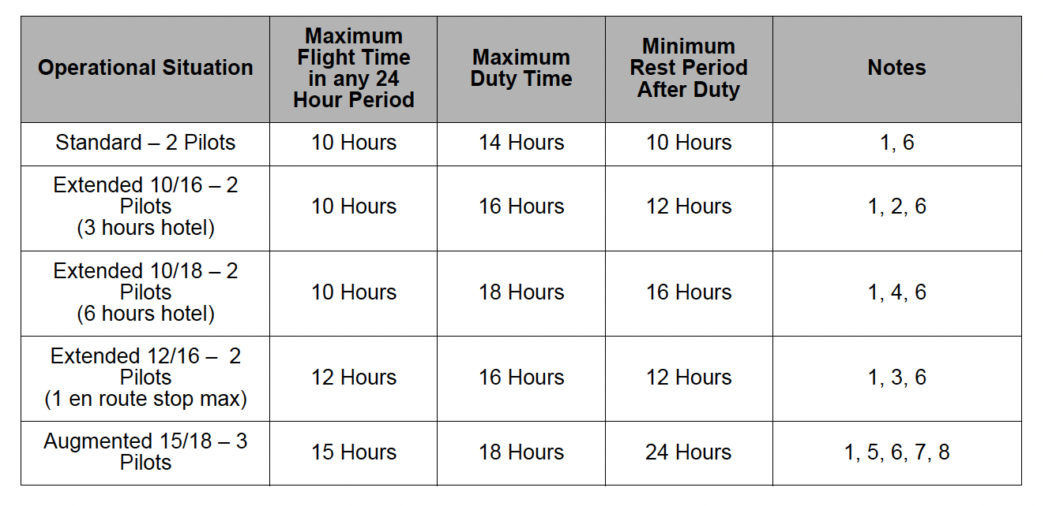

NOTES:

1. Any schedule in excess of the Standard 14 hours duty day period must be approved by the flight crew and documented on the 3.4.3 Duty Day Exception Form.
2. A minimum of 3 hours rest in a hotel.
3. No more than 1 en route stop permitted.
4. A minimum of 6 hours rest in a hotel.
5. No more than 1 en route stop permitted; a maximum of 10 hours flight deck duty time per pilot. PIC can schedule third pilot to report for duty at the en route stop.
6. Rest period must occur during a WOCL.
7. A single reclining seat must be available in the cabin.
8. At least 2 of 3 pilots must be fully PIC qualified.

NOTE 1: For duty periods occurring during a WOCL, see the next section, 3.4.2.1 WOCL Flight and Duty Limitations.
NOTE 2: Four pilot operations will require pre-positioning and are planned using the Standard WOCL or non-WOCL operational situation as two separate flight duty periods, each one its own operational situation.

3.4.2 Window of Circadian Low

The Window of Circadian Low (WOCL) is best estimated to occur during the
hours between 0200 and 0600 local body clock time for individuals adapted to a usual day wake/night sleep schedule. This estimate is calculated from scientific data on the circadian low of performance, alertness, subjective report (i.e.,peak fatigue) and body temperature.

Circadian disruption is the result of travel that crosses multiple time zones. Fatigue management techniques require adjustment of the pilots window of circadian low to account for acclimation to the time zone at the pilots destination. For duty periods that cross three or fewer time zones, the window of circadian low is estimated to be 0200 to 0600 home base/ domicile time.

It can take as much as one day for each time zone traveled for the circadian rhythm to acclimate to the new time zone. For duty periods that cross more than three time zones, the window of circadian low is estimated to be 0200 to 0600 home base/domicile time for the first 48 hours only. After a crewmember remains away from home base/domicile more than 48 hours, the window of circadian low can be estimated to adjust at the rate of 1 hour per time zone traveled for eastward travel and 1.5 hours per time zone traveled for westward travel.

In general, the longer a flight crewmember is away from the home base/ domicile time zone, the more recovery time is needed for readjustment to home base/domicile time. Therefore, duty periods that include crossing four or more time zones and that involve 48 hours or more in a time zone away from the home base/domicile time zone require a minimum of 48 hours off duty to be scheduled upon return to home base/domicile time. This 48 hour period must encompass a minimum of two WOCL periods at the home base time zone. The crewmembers may request additional time.

Window of circadian low operations are defined as a flight duty period in which landing occurs during the WOCL, the flight passes through both sides of the WOCL, or the duty period starts at 0600 or earlier in the WOCL. The following recommended mitigation guidelines related to the window of circadian low will be applied when operations occur within the WOCL.

a. The duty period will not exceed 12 hours. The duty period will be restricted to no more than one takeoff and landing after the duty period penetrates the WOCL
b. The lone exception for duty day exceedance is for the final leg of the day where an unforeseen delay occurs while en route to the final destination. This must be documented on the 3.4.3 Duty Day Exception Form
c. A pilot may not be assigned nor accept a flight scheduled to occur
within the WOCL unless that pilot was free from all duty (including
Standby) beginning at the previous WOCL period until the planned duty start time for that flight
d. The minimum normal post duty rest will be extended to ensure that no duty is assigned before the opportunity for the crew to sleep during their next WOCL period
e. 48 continuous hours off duty required on return home following a duty period crossing more than three time zones
f. Although duty day extensions are prohibited when a flight occurs during the WOCL, the PIC must complete the3.4.3 Duty Day Exception Form to document the WOCL duty and recovery plan
g. When a WOCL operation is planned, a contingency plan must be documented on the 3.4.3 Duty Day Exception Form in the event the flight is delayed for any reason. The contingency must remain within COM guidelines and limitations
h. Duty periods that extend unplanned into the WOCL must be documented post flight on the 3.4.3 Duty Day Exception Form and crewmember recovery must be adjusted appropriately
i. 3.4.3 Duty Day Exception Forms require approval by the Director of Aviation or Chief Pilot and must be submitted to the Director of Safety for analysis

3.4.2.1 WOCL Flight and Duty Limitations

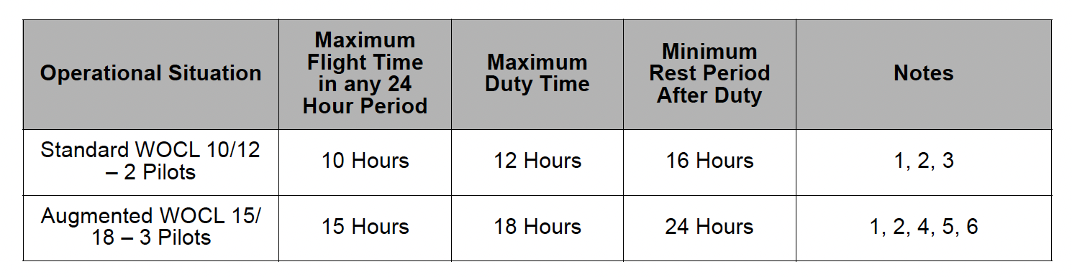

NOTES:

1. A flight and/or duty period that occurs within a WOCL may not be extended and must be documented on the 3.4.3 Duty Day Exception Form.
2. The minimum rest period after duty must encompass an acclimated WOCL period.
3. The duty period is restricted to no more than one takeoff and landing after the duty period penetrates the WOCL.
4. No more than 1 enroute stop permitted; a maximum of 10 hours flight deck duty time per pilot. The PIC can schedule additional pilot to report for duty at the enroute stop (preferred.)
5. A single reclining seat must be available in the cabin.
6. At least 2 of 3 pilots must be fully PIC qualified.

Four pilot operations will require pre-positioning/crew swap and are planned using the Standard WOCL or non-WOCL operational situation as two separate flight duty periods, each one its own operational situation.

3.4.2.2 Acclimated WOCL

It can be helpful to estimate the WOCL period to which the crewmembers
have acclimated in order to plan subsequent flights to remain outside of the flight crew’s acclimated WOCL. The window of circadian low can be estimated to adjust at the rate of 1 hour per time zone for eastward travel and 1.5 hours per time zone for westward travel.

When a trip is expected to return to home base/domicile so that the crew- members are at a different time zone for 48 hours or less, the crewmembers should make every effort to maintain their home base/domicile WOCL period. Hence, any subsequent flights should consider the crew’s home base/domicile WOCL period.

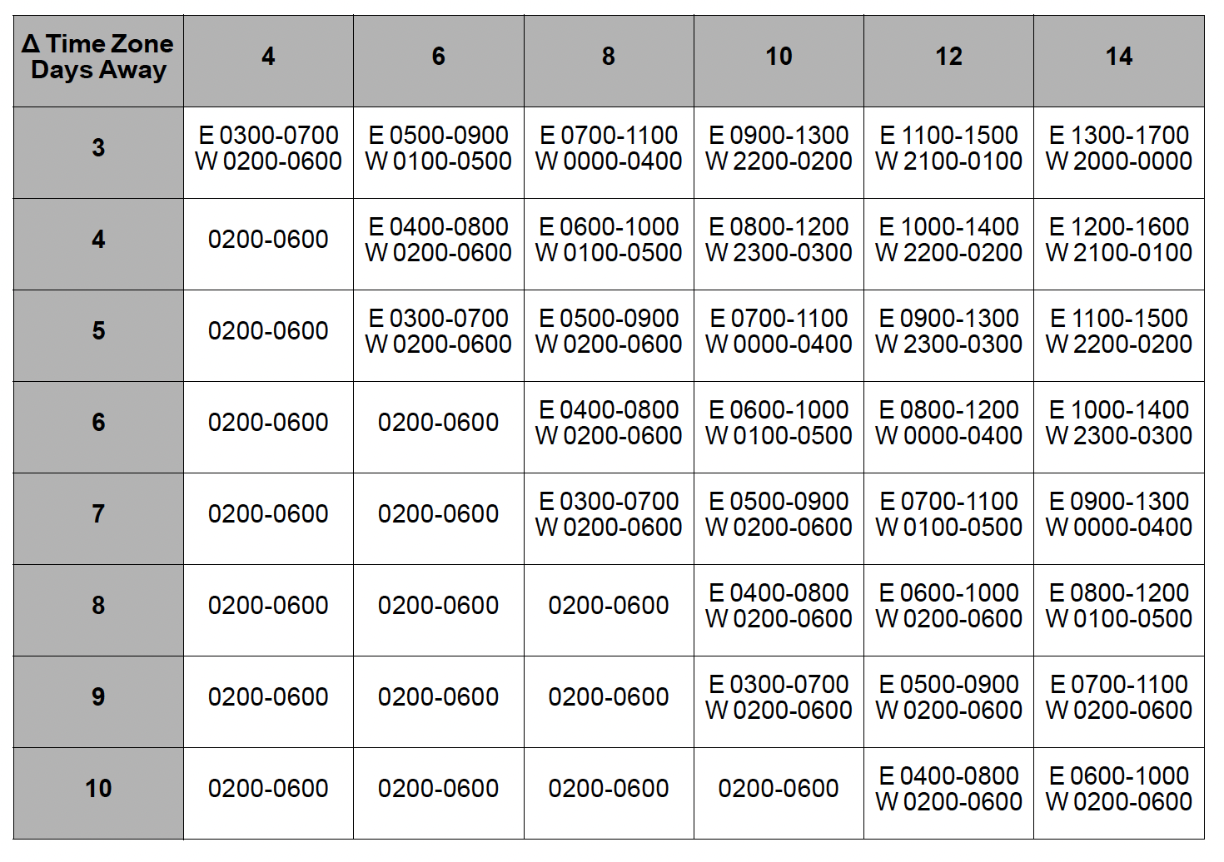
3.4.2.2.1 Estimated WOCL Period at Local Time

Example 1: Westward travel that spans 10 time zones may require 7 days
to fully acclimate to the new time zone. If the next flight is planned 4 days after arrival, every effort should be made to plan the duty period outside of the crew’s acclimated WOCL period of 2300-0300L time.

Example 2: Eastward travel that spans 6 time zones may require 6 days to become fully acclimated. If the next flight is planned 3 days after arrival, every effort should be made to plan the duty period outside of the crew’s acclimated WOCL period of 0500-0900L time.

3.4.3 Duty Day Exception Form

Any schedule in excess of the Standard 14 hours duty day must be
accepted by the flight crew and documented on the Duty Day Exception Form, then submitted to the Chief Pilot, Director of Standards, or the Director of Safety for approval and analysis.

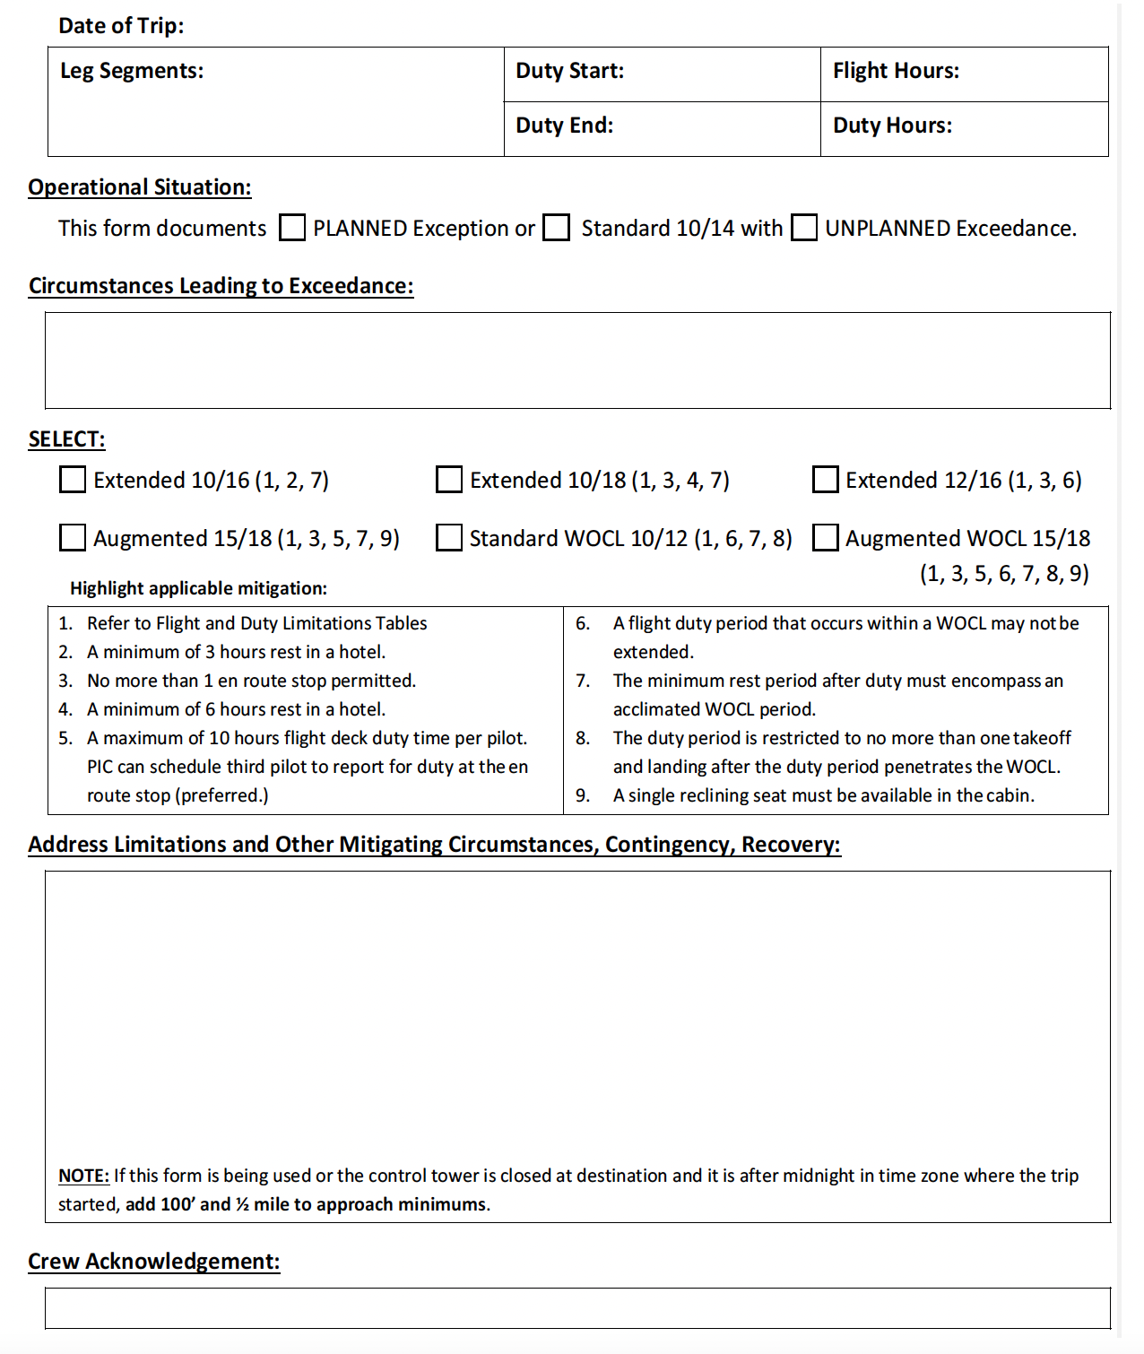

3.4.4 Duty Time Limitations for Non-Aircraft Personnel

When scheduling, Acme Corp Flight Department employees shall limit their duty days to 12 hours, and shall carefully consider the safety risks associated with fatigue and its cumulative effects.

Non-aircraft personnel shall report for duty adequately rested and comply with applicable labor regulations.

3.4.5 Maintenance Personnel Duty Periods

[NX6 3.4.2.8]

Technicians will not be scheduled for duty periods longer than 10 hours. A Technician may extend duty up to 16 hours, but must notify the Director of Maintenance. Approval will be granted if deemed safe.

Following any 10 hour shift or greater, maintenance personnel must receive at least 11 hours off duty, ensuring nine hours of uninterrupted rest. All maintenance personnel have the ability to discontinue maintenance operations when they are fatigued. The Director of Safety will be notified any time maintenance operations are discontinued due to fatigue.

3.4.5.1 Table C – Maintenance Duty Period

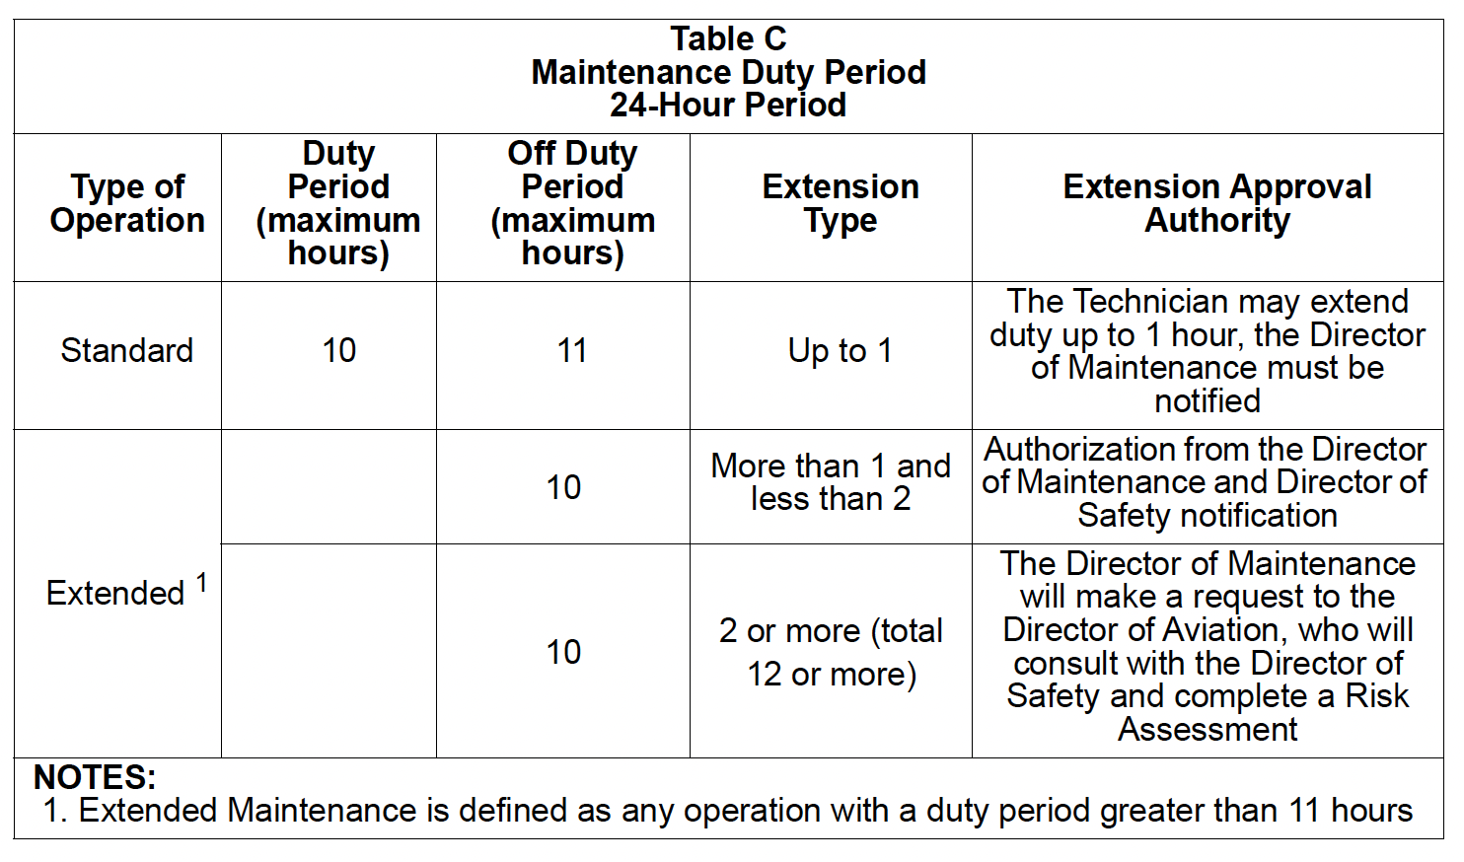
NOTE: See section 2.13.1.5 Scheduling, Ground Crew for 16 contentious hour limit.

3.5 Flight Records

[NX6 3.11.3]

Accurate records of flight activity are required to satisfy business and regulatory requirements.

3.5.1 Aircraft Records

Aircraft Records will have an Inspection Status Report which shows the airworthiness status of the aircraft. This report will show when required inspections, checks, tests, etc. are due.

Aircraft Records will be available electronically during all flights. The PIC will inspect the documents in the Aircraft Records prior to flight and determine the following:

a. Aircraft has been returned to service in an airworthy condition
b. Status of any discrepancies recorded on a previous flight
c. Status of open or deferred items and crew and/or maintenance actions required

3.5.2 Recordkeeping

[14 CFR § 91.417] [NX6 2.6.2.2 and NX6 2.6.2.3]

The following records will be kept for each flight and retained by the Flight Department:

a. Director of Aviation:

i. FOS entry 5 Years
ii. Trip Sheet 5 Years
iii. Flight Schedules 3 Years
iv. Pilot qualification/training records 3 Years
v. Aircraft operating expenses 5 Years

b. Director of Maintenance:

i. Aircraft Maintenance Log 5 Years
ii. Deferred Maintenance Log 5 Years
iii. Permanent aircraft records Until aircraft is sold
iv. Aircraft Flight Logbook Until aircraft is sold

3.6 Personnel Qualified to Taxi Aircraft

[NX6 2.2.2.1]

Aircraft may be taxied by qualified pilots or mechanics. The aircraft will not be moved without at least two qualified personnel in the pilots' seats.

Qualification requirements include:

a. Has been authorized by the Director of Aviation as competent to taxi aircraft and has record of this authorization in his/her personnel training folder
b. Is qualified to use the radio if radio communications are required
c. Has received instruction from a qualified person on airport layout and, where appropriate, information on routes, signs, markings, and lights
d. Has received instruction from a qualified person in ATC signals, instructions, phraseology, and procedures
e. Is able to conform to operational standards required for safe aircraft movement at the airport.

