9 Security Procedures

[NX6 3.13.1]

9.1 Assessing the Threat

[NX6 2.1.1.4]

The first step in the development of an effective security program is to assess the threat against the company, its personnel, aircraft, and facilities. Threats may relate to the nature of the company’s business, where that business is conducted, the nationality of the company or of company aircraft, the profile of passengers carried, and the value of goods carried.

Information on the various kinds of threats Acme Corp Flight Department is subject to will come from a variety of sources. The Director of Aviation will maintain an ongoing assessment of threat to security within the area of company operations. This assessment will be developed in consultation with:

a. Company security officials

b. National and local security officials

c. National and local law enforcement officials

d. National and international business aviation associations

e. Local and foreign media reports

f. Company officials posted in foreign locations

9.2 Preventive Measures

Preventive security measures seek to prevent:

a. Unauthorized access to company aircraft and facilities

b. Unauthorized introduction of weapons and explosives onto company aircraft and into company facilities

c. Use of company aircraft to commit other unlawful acts, such as the transport of illicit drugs

Acme Corp Flight Department flight information (i.e., times, dates, destinations, passenger lists, etc.) should be treated as proprietary and shared only with those persons having a reason to know.

9.2.1 Hangar Security

a. Positive identification should be made of personnel entering the confines of the hangar/ramp areas

b. Visitors should be scheduled as a group, when possible, and escorted by an employee

c. Flight crew should wear their IBAC ID badges while in the hangar facilities

d. The points of entry into the hangar area will remain locked

e. Other entries into the facilities must remain supervised and restricted to Acme Corp Flight Department personnel or guests

f. Only flight operations employees are permitted to access ramp areas by passenger vehicle

g. Acme Corp Flight Department employees may permit access to the shared hangar through the office only for Acme Corp Flight Department passengers or guests

9.2.2 Aircraft Security

a. Aircraft unattended by Acme Corp Flight Department personnel must have their doors secured and should be parked in areas not conducive to vandalism or sabotage. Additionally, to preclude the possibility of accidental damage by vehicles or taxiing aircraft, company aircraft should be positioned in well lighted areas and/or in areas where they are clearly visible. If local conditions require enhanced security, experienced personnel should be retained

b. Complete interior and exterior inspections should be made prior to each new complete start up cycle of an unattended aircraft

c. Unless hangared in company facilities, when the aircraft doors are open, the aircraft shall not be out of visual range of a company lineman, technician, or crewmember

d. When the aircraft is being serviced, at least one company lineman, technician, or crewmember shall be in the immediate vicinity

e. When operating an aircraft APU, a crewmember or company technician shall be in the aircraft or in the immediate vicinity

f. When airport security is limited suspect, the PIC must ensure the aircraft is airworthy prior to departure. Measures to consider include but are not limited to: locking doors, emergency exits, fueling panels, maintenance access doors, arming security devices, taping cabinets and access panels, and disconnecting batteries and start connectors

g. Any maintenance or line personnel not associated with Acme Corp Flight Department who board the aircraft must be accompanied by a crewmember

h. Crewmembers should monitor fueling. If malicious intent is suspected, crews should determine, either directly from the truck pump or from fuel samples taken by the FBO, that the fuel is pure

i. When operating away from company facilities, the crew should always leave a local contact telephone number with the FBO

9.2.3 Accepting Material for Transport on Company Aircraft

When Acme Corp Flight Department is requested to accept unaccompanied packages for transport on company aircraft, the following must occur:

a. Acme Corp Flight Department employees should have prior clearance from the Director of Aviation and/or the appropriate executive

b. The Pilot in Command (PIC) must approve loading of the package prior to placing it on the aircraft

c. The identity of the person delivering or picking up the package must be known or verified

d. Any suspicious package should be left undisturbed and the proper authorities notified

9.3 Responsive Measures

[NX6 2.9.2]

a. In the case of a hijacking or bomb threats, the PIC will follow the procedures set out in the Emergency Response Program

b. In the case of other unlawful acts, the PIC should contact the responsible law enforcement agencies

9.4 Security Checklists

The PIC must ensure that destination airport(s) and surroundings on a given itinerary do not present a threat to air safety. Corporate security and when flying internationally, local embassies and the state department should be used as valuable resources. If civil or political situations deteriorate while away from home base, the PIC and/or Acme Corp Flight Department will take appropriate action to protect the company’s passengers and aircraft. The table below describes safety actions to be taken for various threat levels. For Orange and Yellow levels, actions for both that level and lower levels should be taken.

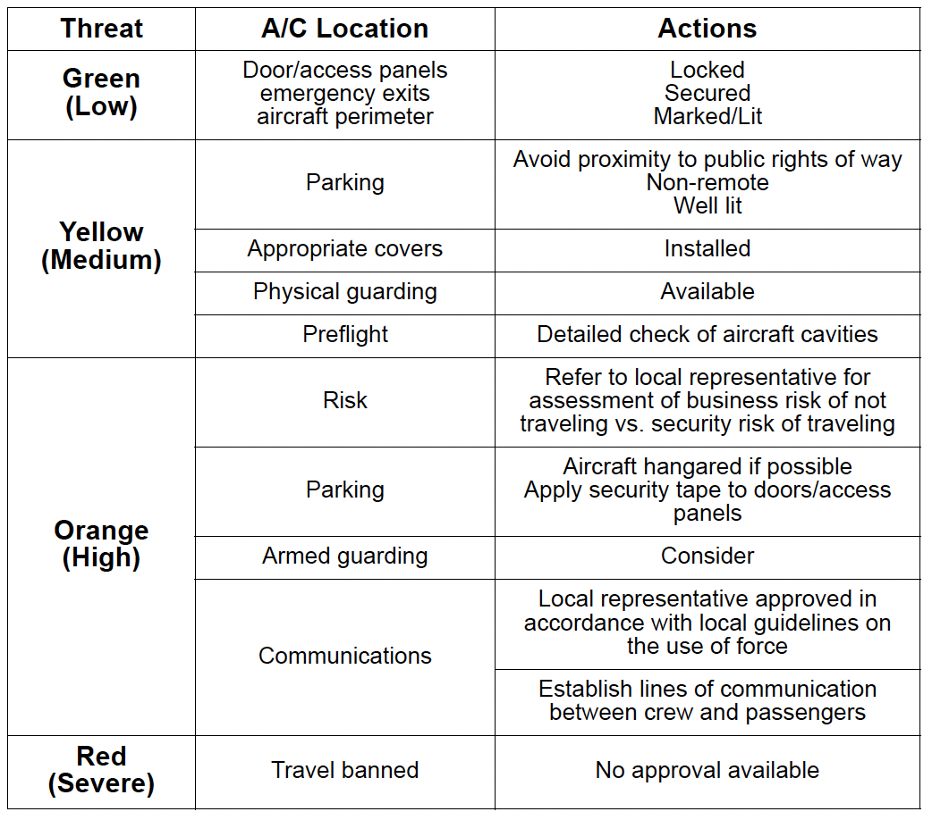

Acme Corp Flight Department will provide its crews with assessments of the security situation by local specialists in countries where there is a local presence. Whenever possible the aircraft should be hangared for stays in foreign countries. The crew should contact Acme Corp Flight Department for this assistance.

